

**COMP2043.GRP Interim Group Report Mobile system for monitoring vital signs**

**UNIVERSITY OF NOTTINGHAM NINGBO CHINA**

**SUPERVISED BY PROF. VLADIMIR BRUSIC**



Haonan Chen

Xiaotian Xia

Hudie Liu

Rongjiang Yang

Yiyang Li

**DATE:14. DECEMBER 2020**

**Contents**

**1 Introduction1**

1.1 Introduction2

1.2 Background2

1.3 Motivation2

1.4 Aims and Objectives2

1.5 Team Members and Roles2

**2. Background Information and Research4**

2.1 Literature Review5

2.2 Technology Research5

2.2.1 wearable sensor technology5

2.2.2 Involving Equipment5

**3. Requirement4**

3.1 Requirement Elicitation5

3.2 Requirement Specification5

3.3 Requirement Validation5

3.4 Functional Requirement5

3.5 Non-Functional Requirement5

**4. Initial Design4**

4.1 Platform5

4.2 Time Plan5

4.3 UML Diagrams5

4.4 System Design5

4.5 Prototypes5

**5. Implementation4**

5.1 Supporting Devices5

5.2 Supporting Algorithm5

5.3 Ideas5

**6. Problem Encountered4**

6.1 Technical5

6.1.1 Measurement Algorithm5

6.2 Interpersonal5

6.2.1 Stakeholders5

6.2.2 Team5

**7. Summary4**

7.1 Project Management5

7.1 Future Plan5

**Appendices4**

A. Meetings Records5

B. Reference5

1. **Introduction**
   1. **Overview**

Vital signs are used in medicine to determine the severity and urgency of a patient’s physical condition. The four major components are respiration, body temperature, pulse, and blood temperature. Vital signs are of great significance to the predication of serious disease such as cardiovascular and diabetes mellitus. Our project is about developing a mobile system of monitoring the vital signs. This project focuses on the data capturing from the wearable devices and data processing before showing on mobile system.

* 1. **Background**

To curb the growing incidence of diseases, technology to monitor vital signs is becoming increasingly significant. According to the statistics from WTO, cardiovascular disease (CVDs) is the most fatal of death worldwide, the rate of death is always at the top among all disease. **[1]**. Diabetes mellitus (DM) is considered as a global epidemic, which makes a great influence on global population. Due to an approximately estimation, 6%-8% of world’s population is suffer from DM. Compared to the number of 336 million affected people in 2011, it predicts that in 2030, the increase will be 50.8% and nearly 552 million people will involve in DM **[2]**.

Therefore, it is vital important for researchers to develop new technology to monitor the signs. Numerous investigations have been devoted to vital signs. It is proved that by the combination of machine learning with monitored data, it can improve the prediction accuracy of cardiovascular.**[3]** However, it is not adequate to meet the requirements of every user. For the pregnancy, mood symptoms are especially important. Prenatal depression can cause serious complications which are harmful for both pregnancies and fetus.**[4]**

* 1. **Motivation**

There are already many different systems on the market, such as Apple, Xiaomi, and Huawei. In general, these systems all have basic functions such as measuring heart rate or temperature. However, there is no integrated system designed for the pregnancy women. For example, the Xiaomi system is inadequate in monitoring heart rate, users cannot view tracks by period. For Huawei system, its data reception is unstable which may lead to the imprecision of receiving data. This cluster of data monitoring is not user friendly. An­­ ideal system should not only has the basic functions, but also has extra functions designed for the pregnancy. The system could compare the user’s data with the average data, producing line charts for user to check. Moreover, the system could integrate all the statistics received from the devices and automatically output a report with some suggestions for user.

* 1. **Aims & Objectives**

Our main purpose aims to build a system that integrate all data and generate a report for the user. Considering the open source information currently available on the device, an Android application will be developed. The system can monitor the users’ health condition (eg. heart rate, blood pressure…) and output a report for the user. In addition, the algorithm applied algorithm developed by the PhDs and research team.

* 1. **Team Members and Roles**

Haonan Chen: Team Leader, documentation writer, repository master, meeting organizer

Hudie Liu: Monitor, designer, Tester, website maintainer

Xiaotian Xia: Project Manager, researcher

Yiyang Li: Schedular, documentation writer, file manager

Rongjiang Yang: Technical Leader, Code Master, repository master

1. **Background Information and Research**
   1. **Literature Review**

Wearable devices make it possible to monitor health in home and enable early detection of disease in body. The wearable devices that already used in daily lives includes wristbands, smart clothing such as smart socks and wearable healthcare bracelets, legbands, and body sensors [5]. The data captured by these devices (weight, heart rate, blood pressure) could be integrated for health monitoring and disease prediction. Smart sock is one of the wearable devices on the market. Abnormal foot pressures can be indications for many physical diseases such as diabetes, obesity and rheumatoid arthritis. Smart sock is designed based on that which also captured the data and analyze by its system on application [6]. However, an application with graphical foot pressure is need. Furthermore, the result is not accurate enough because the analysis based on single foot pressure data is too small. Wearable healthcare bracelets are also a product which are popular in recent years.

Through the bracelet, users can record real-time data of exercise, sleep and diet in daily life, and synchronize these data with mobile phones and computers, so as to guide healthy life through data. Date of daily exercise routes, calories consumed, and calories consumed can also been stored by the bracelet. Nevertheless, the bracelet focuses on real-time health data such as heart rate and emergency scenarios which ignores long-term health monitoring and prediction of many chronic diseases. [7] [8]A body sensor network for mobile healthcare monitoring has been used in Australia. The body sensor measures the patients’ biosignals. The biosignals are transmitted over wireless communication links to remote locations where have experts to view the biosignals and give some advice. [9] This device is only suitable for patients and needs cooperation of medical experts which is difficult for promotion of public.

This device uses several vital signs for health monitoring and disease predictions. Based on enough data, it makes the result more accurate. Additionally, the data are all important data for physical condition analysis. It focuses on long term health monitoring which makes the result more accurate. In addition, the device integrates several kinds of physical data to show to the user so it is convenient and can be promoted to the public.

* 1. **Technology Research**

2.2.1 wearable sensor technology

Nowadays, some new technologies make it possible to improve the vital sign monitoring system, which include sensor systems [10], wearables [11], personal pregnancy health records [12], and the connectivity of devices through Internet of Things [13]. With the development of those technologies, the wearable sensors get rapid developed as well. These sensors are portable, accurate, and can monitor vital signs in real time. And they have been applied in multiple devices that can be integrated into the vital sign monitor system.

2.2.2 Involving Equipment

1. Polar H10 is a chest strap whose heart rate sensor can precisely monitor heart rate in real time. It has built-in memory to store data and uses Bluetooth to transfer data. It could be integrated system to gather the heart rate data.

2. RENPHO Body Fat Scale is a smart scale to measure body weight, and transfer data using Bluetooth to get further analysis. It could be integrated system to gather the body weight.

1. **Software Requirement**

Software Requirements engineering are the descriptions of what the system should do [14]. These roles calcify the kernel requirements stakeholders need to integrate in this product and details of system functions which guide how system will be implemented. This mobile system is designed to monitor their vital signs, make the analysis report, and help them keep healthy. Our project consisted of two different stakeholders (Research group and users), who had different requirements and needed to clarify them in different ways. We need to check with them about the requirements and get them right at the first stage in our project. The requirement elicitation below is necessary and helpful to specify clients’ requirements accurate.

**3.1 Requirement Elicitation**

The stakeholders of our project are Professor Vladimir’s research group (Customer) and application users (User). Our project is a part of the whole research group about mental health monitoring. PhD students will use our application for some academic research and tests. Our purpose is developing a mobile system to support existing algorithm about data processing and analyzing. The main methods we decided to gain the requirements are literature research and interviews or investigations with stakeholders in the workshop. According to research and survey, we needed to find the features of target users, the kernel requirements, and the user feedback of some existing systems.

**3.2 Requirement Specification**

User requirements contained functional and non-functional. Functional requirements clarify the kernel functions the application supplies to users and define what a software system should do, which was asked by customers. In contrast, non-functional requirements consider the constraints on the functions offered by the system [7]. According to the user requirement, system specification was clarified, which explained the details of how the system will meet each requirement content and provide a guidance of system design.

Our stakeholders gave us clear request of software: developing a mobile system to connect with wearable devices and capture data from them, then process and integrate the data. In mobile side, users need to see the current body situation report and long-term integrated report. The analysis and recommendation algorithm of data will be provided, the further use of data need not to be considered. The kernel function is capture and transform data. For advanced tasks, will can integrate multiple vital signs and generate the comprehensive report.

**3.3 Requirement Validation**

In the early stage of gathering requirement, we understood the targets of our stakeholders. After the first interview with customers, some approximate requirements were given. Then we made the draft of requirement documentation and discuss with our customers to modify the details of user requirements and scenarios, validate roles, and add some extra roles. Following the software engineering process, we planned to continually gather the kernel requirements for several weeks and finally confirmed the final requirement documentation.

**3.4 User Requirement**

This part specifies the requirements considered by normal users and the special target users, for example: users with heart diseases, pregnant women. Here are the requirements from research and meeting communication with customers.

**Functional Requirement**

* 1. **Connection**

The user could use the application to connect with the wearable devices.

* 1. **Monitoring**

Pregnant users are concerned about their health conditions and want to know the current body states and if they are healthy.

* 1. **Comprehensive Report**

Users want to be given a comprehensive report about their bodies which could help them to understand their health conditions and life advices.

**Non-functional Requirement**

* 1. **Useability**

Users want their body data visualized and easy to understand. Users also want a low threshold to use the application and to be reminded to use the application.

* 1. **Emergency dealing**

Users do not want to wear the wearable devices too long throughout the day. They might take off the wearable devices sometimes.

**3.5 System Specification**

The details of system specification are at the **Appendix 2.**

1. **Initial Design**

**4.1 Technical Specification**

1. The mobile system should support the device types:
   * + - (Heart Rate) Chest belt: **Polar H10**
       - (Brain Wave) Brain belt: **NeuroSky TGAM**
       - Smart Scale: **Yunmai**
2. The wearable devices official SDK is open source for the development and will be used during the project.
3. The development platform is android studio, and the development language is Java.
4. The mobile system will operate in PC for demonstration (simulator) and on android cellular phone with Android 11 system.
5. The simulator of mobile system is GenyMotion/AVD emulator. It will be used to simulate the process of mobile system for demonstration and test.
6. The data to test is from the research group which include the weight change of pregnant women and references.

**4.2 Project Schedule and Plan**

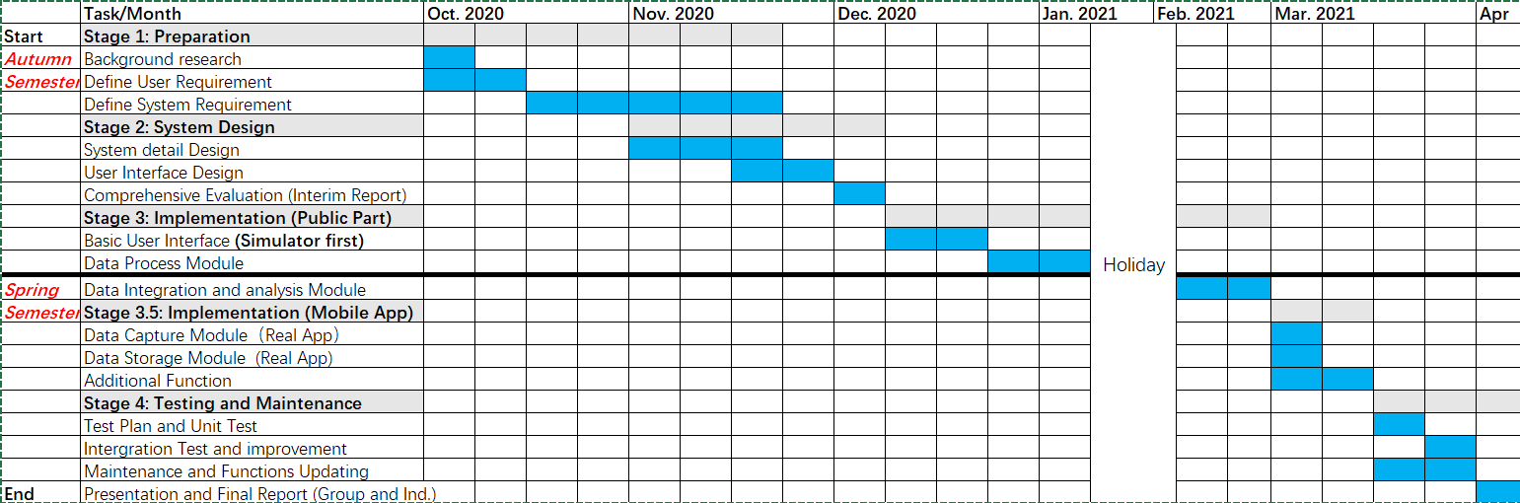The project was divided into four stage, which respectively are preparation, system design, implementation, and testing. The Gantt graph of the whole project is shown below:

**4.3 UML Diagram**

The UML diagrams are in the Appendix.

**4.4 System Design**

The whole mobile system according to the requirement specifications can be divided into five main modules: data capture module, data integration module, data analysis module, data storage module, task management module. The system’s task is to connect with mobile devices and capture data from them. Then shows the data after processing in the stage of application for user view and finally generate a report that includes vital signs daily review, analysis, and advices.

**Data Capture Module**

This module is used to capture the data from wearable devices. After making connections with wearable devices, the application will request keeping in the background to operating system and receive the body data every minutes. The data capturing is continuous until the system detects that signal is interrupted. That means user might take off the devices or the sensor is not taken at the correct position.

**Data Integration Analysis Module**

This module is used to process, clean, and integrate the initial data from capture module. The raw data received from wearable devices is hard to understand by users, so this module is used to process the integrated data by algorithm and generate a report of users’ health conditions. The report includes the time of fastest heart rate, the time of slowest heart rate, the heart rate change graph, the walk average heart rate and resting average heart rate. The report should combine multiple parameters and give a visualized result.

**Data Storage Module**

This module is used to store the data and report. This module is in the local mobile system. After every measurement the user data need to be stored in the mobile phone and could be accessed by user anytime.

**Task Management Module**

This module is GUI and tasks of user messages. The users could set their body parameter and message push mechanism in Setting. User can change the view of data here and export the report for further use.

**4.5 Prototype**

To help stakeholders validate the requirement and get an insight about how the software would look like, we drew low-fidelity prototypes.

The first image in Figure (1) is the app’s home page. Users can see the graph of real-time data captured by the app from wearable devices. There is a switch button to help the user decide whether to start to capture data or not.

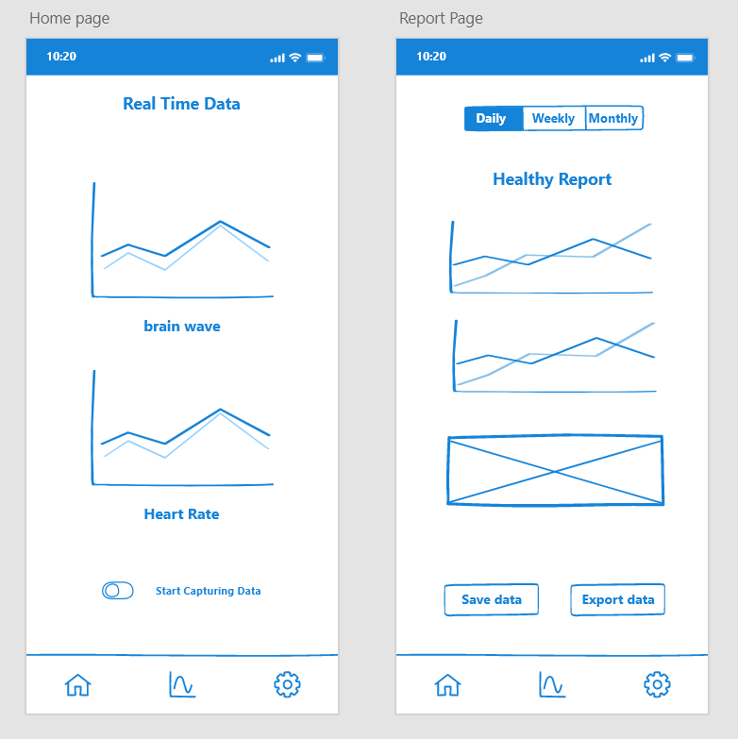When the user clicks the middle button in the bottom navigation bar, the report page will show the second image in Figure (1). Daily, weekly, and monthly reports can be chosen to see. In addition, users can save these data to their mobile phone or export data to a computer if they want.

Figure 1

The setting page (Figure 3) contains three functions: connect to wearable devices, record, or display weight, and provide some options to the user. If customers use this app for the first time, they need to connect devices first. After this step, every time they click on this page, a connecting situation will be displayed.

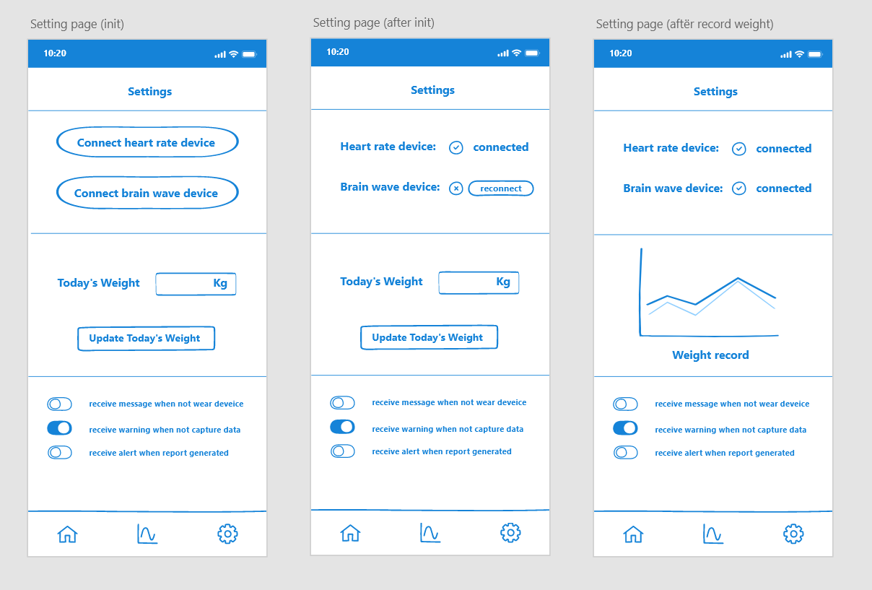Additionally, users should weigh themselves and record data on this page. The weight trend will show after this step.

Figure 2

1. **Implementation**

Not finished

1. **Problem Encountered**

**Technical**

1. Android or IOS

The main aim of our project is to develop software for users’ mobile phones, which means we must decide to develop on the Android platform or the IOS platform. Considered of learning cost and laptops we have; we decide to develop this app on the Android platform.

2. Framework things

Use a framework like React to develop software will ease our job, but it is necessary to connect our app to some mobile device, which means some related SDK will be used. After a group discussion, we decided not to use the framework to develop this app currently.

3. Data storage

Because data that capture and process by our software are requested to be used in further study, how to store the data becomes a problem.

**Stakeholders**

1. Requirement gathering problem

What stakeholders want is very easy and simple, but our team thought it difficult. For example, we planned to give users a healthy report that includes data measurement, data diagram as well as some medical and professional advice. What stakeholders want is just a report of data measurement, and the report should be exportable so that the data can be used in further research or analysis.

2. Formal meeting issue

In the first few meetings, we did not have a clear project plan or timeline, so the supervisor cannot have a good understanding of what we have done. After meetings, we make a clear plan and point out what we have finished, what we should do next.

**7. Summary**

Not finished Technical

**Appendix 1: Specification Details**

#### Functional Specification

1. **Data Capture Function.**

The mobile system (Android Application) can connect with the wearable devices which include heart rate belts, brain ware, smart scale.

1.1 The vital data will be sent from wearable device to mobile application every minute.

1.2 The bodyweight data is captured by manual record.

1.3 The year and height are recorded from users.

1.4 The data will be sent to the integration module for the next step.

1.5 When the application detects that the data signals is interrupt or zero, the capturing will stop.

1. **Data Integration Function.**

2.1 The data will be processed and temporarily store in the application's memory.

2.2 The initial data will be checked, and the error data will be cleaned.

2.3 Multiply types of data can be integration in the mobile system.

2.4 The data will be split into different categories and shown to the users.

2.5 The data will be sent to the analysis module for the next step.

2.6 When the application captures and process data more than 30 minutes, the current report will be generated. This report is about analysis of the past period.

2.7 The report is about his/her body data. The report will include every-day vital signs data after processing and warn users if find abnormal status.

2.8 The system could generate the long-term report daily and monthly (or weekly).

2.9 The report could be preserved by users and exported.

2.10 The analysis in report is just for reference and cannot be correct and accurate. Report will ask user to see doctor for the further diagnosis.

2.11 When the system detects the short interrupt (less than 1 minutes), the data collection is continued without 30 minutes re-collection.

2.12 The data transmission between wearable devices and mobile application is based on blue-tooth protocol.

1. **Data storage Function**

3.1 The data from users should be stored both in PC and mobile system.

3.2 The received data will be stored for a month in the application memory for users' views.

3.3 Considering the limited memory, the details of past data will be cleaned up and the daily report will be stored in the mobile system.

3.4 The user could connect with the PC monthly and send the data for the long-term storage.

1. **Task management (interface)**

4.1 The system will push the every-day reports, suggestions, and analysis at 8 a.m.

4.2 The system will send a message to user if user does not. wear the devices.

4.3 The data capture function can be switch on/off.

4.4 When the application cannot find the data, application will remind user to check the wearable device wearing.

4.5 The system will send a message if the user does not record the body weight until 8 p.m. every day.

4.6 The user can view four mode of application:

* + - * + current/last measured data
        + today's report
        + Long term report
        + Settings

#### Non-functional Specification

* + - **Security**
  1. To prove the security of personal data, the storage module needs to be private with the outside system.
  2. The wearable device connections should be confirmed by users. User can cancel the connections at any time.
     + **Performance**
  3. The advice and message should be accurate and on time.
  4. Use the suitable data analysis algorithm to prove the correctness of data, and error data need to be cleaned.
     + **compatibility**
  5. The application should be compatible for android platform.
  6. The application User interface should be compatible for different size of screen.
  7. The advice should be given according to user status
  8. System should deal with exception of data.

### Technical Specification

1. The mobile system should support the device types:
   * + - (Heart Rate) Chest belt: **Polar H10**
       - (Brain Wave) Brain belt: **NeuroSky TGAM**
       - Smart Scale: **Yunmai**
2. The wearable devices official SDK is open source for the development and will be used during the project.
3. The development platform is android studio, and the development language is Java.
4. The mobile system will operate in PC for demonstration (simulator) and on android cellular phone with Android 11 system.
5. The simulator of mobile system is GenyMotion/AVD emulator. It will be used to simulate the process of mobile system for demonstration and test.
6. The data to test is from the research group which include the weight change of pregnant women and references.

**Appendix 2: UML Diagram**

Use Case Diagram:

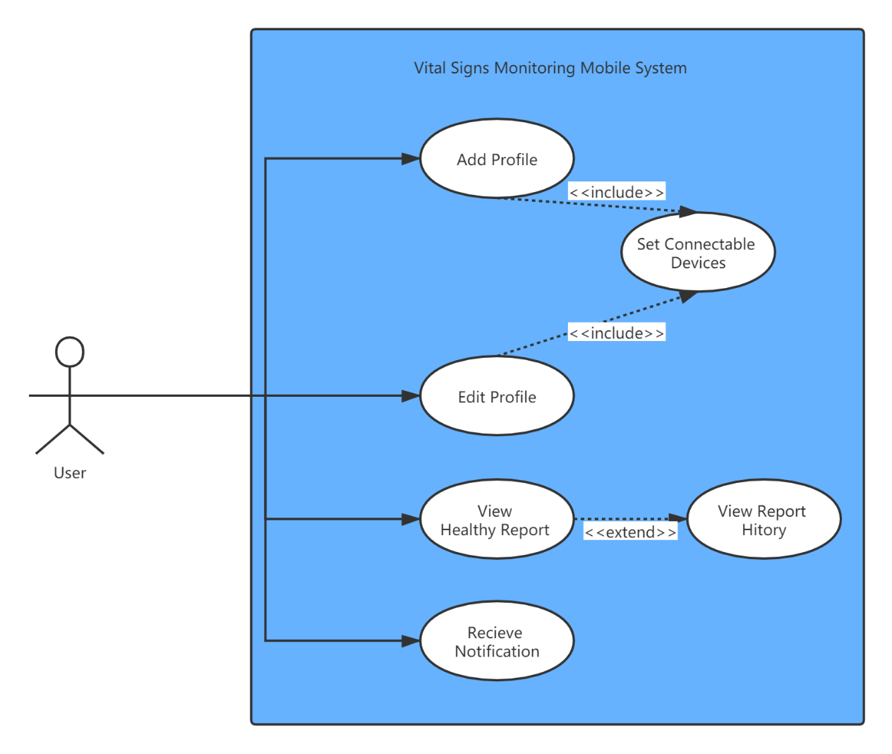

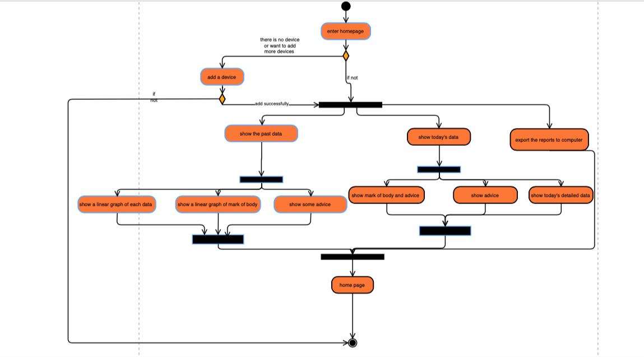**Activity Diagram:**

**Sequence Diagram:**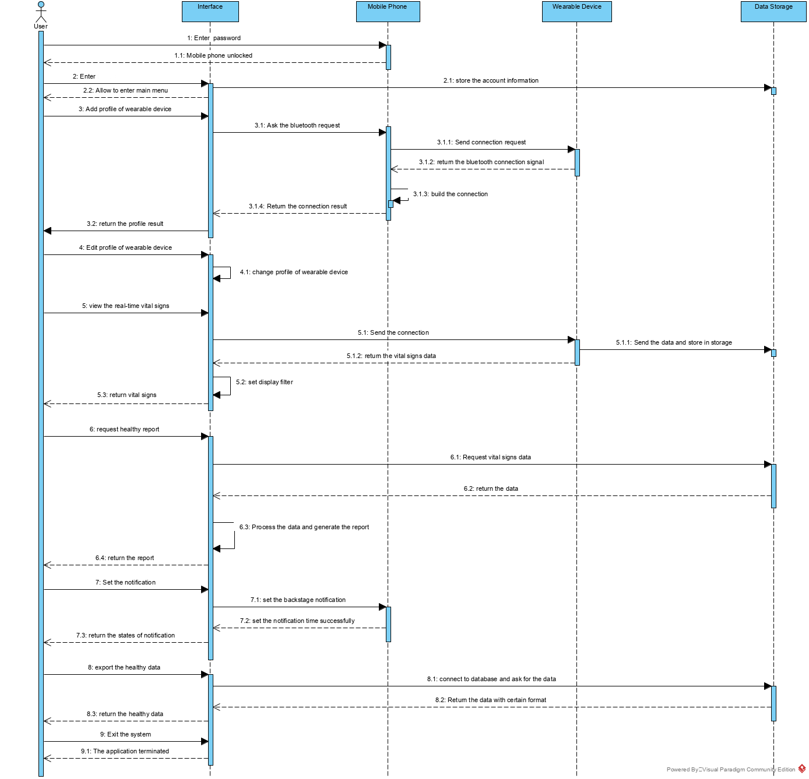

**Appendix 3: Schedule Detail**

Details Timetable is shown below:

|  |  |  |  |
| --- | --- | --- | --- |
|  | **start** | **spend** | **finish** |
| **Bid submission** | **2020/9/25** | **11** | **2020/10/6** |
| **equipment requests** | **2020/10/6** | **205** | **2021/4/18** |
| **1 Define specification** | **2020/10/6** | **30** | **2020/11/5** |
| **Finish group project site up** | **2020/10/6** | **22** | **2020/10/28** |
| 1.1 Interview users(supervisor) | 2020/10/6 | 6 | 2020/10/12 |
| 1.2 Define user requirements | 2020/10/12 | 6 | 2020/10/18 |
| **Project Plan** | **2020/11/5** | **38** | **2020/12/13** |
| 1.3 Define system requirements | 2020/10/18 | 6 | 2020/10/24 |
| 1.4 Interpret equipment requests | 2020/10/24 | 6 | 2020/10/30 |
| 1.5 Indentify data requirements | 2020/10/30 | 6 | 2020/11/5 |
| **2 System & Software design** | **2020/11/5** | **30** | **2020/12/5** |
| 2.1 General design | 2020/11/5 | 4 | 2020/11/9 |
| 2.2 UI design | 2020/11/9 | 3 | 2020/11/12 |
| 2.3 Modeling design | 2020/11/12 | 5 | 2020/11/17 |
| 2.4 Algorithm implementation | 2020/11/17 | 3 | 2020/11/20 |
| 2.5 Comprehensive evaluation | 2020/11/20 | 5 | 2020/11/25 |
| **Interim report** | **2020/11/25** | **19** | **2020/12/14** |
| **3 Implementation & coding** | **2020/11/25** | **52** | **2021/1/16** |
| 3.1 Realize UI | 2020/11/25 | 12 | 2020/12/7 |
| 3.2 Build & implement mathmatical model | 2020/12/7 | 20 | 2020/12/27 |
| 3.3 Establish database | 2020/12/27 | 17 | 2021/1/13 |
| 3.4 Implementation of EA version | 2021/1/13 | 11 | 2021/1/24 |
| **4 Testing & refactoring** | **2021/1/24** | **40** | **2021/3/5** |
| 4.1 Test plan | 2021/1/24 | 10 | 2021/2/3 |
| 4.2 Unit test | 2021/2/3 | 10 | 2021/2/13 |
| 4.3 Intergration testing | 2021/2/13 | 10 | 2021/2/23 |
| 4.4 Debugging & Refactoring | 2021/2/23 | 10 | 2021/3/5 |
| **5 Updating & Maintenance** | **2021/2/23** | **45** | **2021/4/9** |
| 5.1 Functions updating | 2021/2/23 | 18 | 2021/3/13 |
| 5.2 System maintenance | 2021/3/13 | 27 | 2021/4/9 |
| **Team final reports & software** | **2021/1/24** | **75** | **2021/4/9** |
| **Software Demonstration & Team presentation** | **2021/2/23** | **45** | **2021/4/9** |
| **Preparation for Open day & Presentation & Team live Q&A** | **2021/2/23** | **50** | **2021/4/14** |
| **Individual final reports due** | **2020/11/25** | **145** | **2021/4/19** |

**Appendix 4: Reference**

1. 17 May 2017, Cardiovascular diseases (CVDs), http://www.who.int/news-room/fact-sheets/detail/cardiovascular-diseases-(cvds)

2. Anselmo J, Ryan A, Enrique A, Ycly J, Alberto C, Enrique J, 2015, Diabetes in Panama: Epidemiology, Risk Factors and Clinical Management

3. Bharah A, Xiaoying Y, Colin Wu, Kiang Liu, Gregory H, Royhn Mc, Antoinette S, Aaron R, Steven S, Eliseo G, David B, [João](https://www.ncbi.nlm.nih.gov/pubmed/?term=Lima%20JA%5BAuthor%5D&cauthor=true&cauthor_uid=28794054) A. 2017. Cardiovascular Event Prediction by Machine Learning: The Multi-Ethnic Study of Atherosclerosis

4. Marcus, S.M., 2009. Depression during pregnancy: rates, risks and consequences. Journal of Population Therapeutics and Clinical Pharmacology, 16(1).

5. Dunn, J., Runge, R. and Snyder, M., 2018. Wearables and the medical revolution. Personalized medicine, 15(5), pp.429-448.

6. Lin X, Seet B C. Battery-free smart sock for abnormal relative plantar pressure monitoring[J]. IEEE transactions on biomedical circuits and systems, 2016, 11(2): 464-473.

7. Angelini L, Caon M, Carrino S, et al. Designing a desirable smart bracelet for older adults[C]//Proceedings of the 2013 ACM conference on Pervasive and ubiquitous computing adjunct publication. 2013: 425-434.

8. Matias I, Pombo N, Garcia N M. Towards a Fully Automated Bracelet for Health Emergency Solution[C]//IoTBDS. 2018: 307-314.

9. Jones V, Gay V, Leijdekkers P. Body sensor networks for mobile health monitoring: Experience in europe and australia[C]//2010 Fourth International Conference on Digital Society. IEEE, 2010: 204-209.

10. Tricoli A, Nasiri N, De S. Wearable and miniaturized sensor technologies for personalized and preventive medicine. Advanced Functional Materials. 2017 Apr;27(15):1605271.

11. Piwek L, Ellis DA, Andrews S, Joinson A. The rise of consumer health wearables: promises and barriers. PLoS Medicine. 2016 Feb 2;13(2):e1001953.

12. Smith MI, Garcia G, Simon M, Bruchanski L, Frangella J, Sommer JA, Giussi MV, Luna DR. Lessons Learned After Redesigning a Personal Health Record. InMEDINFO 2017: Precision Healthcare Through Informatics: Proceedings of the 16th World Congress on Medical and Health Informatics 2018 Jan 31 (Vol. 245, p. 216). IOS Press.

13. Al-Fuqaha A, Guizani M, Mohammadi M, Aledhari M, Ayyash M. Internet of things: A survey on enabling technologies, protocols, and applications. IEEE Communications Surveys & Tutorials. 2015 Jun 15;17(4):2347-76.

14. Somerville, Ian. (2011). Software Engineering. 9th ed. Addison-Wesley. pp 147-202